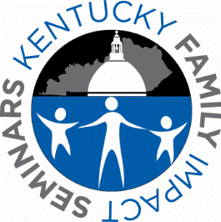

4th Kentucky Family Impact Seminar
Transitioning from Foster Care to Adulthood
February 21, 2017
Summary

Seminar Speakers
Overview of Kentucky’s Foster Care Youth Transitioning into Adulthood
Dr. Justin “Jay” Miller, Assistant Professor, College of Social Work, University of Kentucky

Adolescent Developmental Turning Points
Dr. Alexander T. Vazsonyi, Endowed Professor,
Department of Family Sciences,
School of Human Environmental Sciences,
University of Kentucky
Presented by Gabriela Jiskrova,
Doctoral Student, Department of Family Sciences, University of Kentucky

The Difficult Transition to Adulthood for Foster Youth in the U.S.: Implications for the State as Corporate Parent
Dr. Mark E. Courtney
School of Social Service Administration,
University of Chicago

Seminar Attendance (Total = 33)
Legislators - 18 (representing 46 counties)
Legislative Research Commission (LRC) - 2
Attorney General’s Office - 1
Cabinet for Health & Family Services - 5
U of KY Administration/Faculty/Staff- 7

For audio recordings and PowerPoints
of speaker presentations, please visit our
website at hes.uky.edu/fis.
Attendance Facts
- 9 Senators and 9 Representatives attended the seminar, lunch discussion session and/or collected seminar materials.
- The Deputy Secretary of the Cabinet for Health & Family Services attended.
- 4 social workers in the Cabinet for Health & Family Services attended.
- 1 attorney attended from the Attorney General’s Office.
- 9 people from LRC and U of KY Administration, Faculty & Staff attended.

Participant Ratings of the Seminar
Participants completing the evaluation reported that the seminar helped increase their understanding of the topic by provided high-quality research that was objective, relevant to their needs and interests, and useful in their current role. Overall, the participants rated the policy options presented as practical, economically feasible and innovative.

