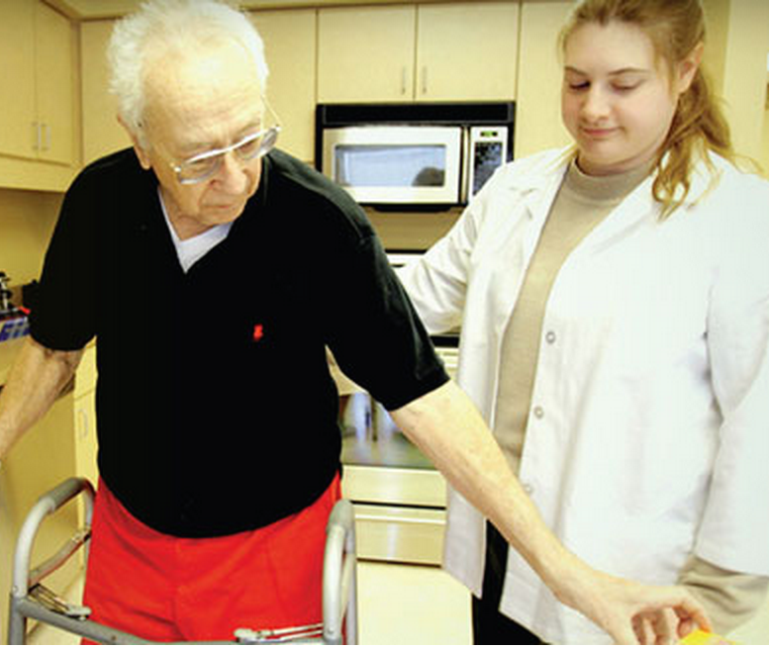

***Mental Health and Rural Iowans***

The tangled bureaucracy created to address mental health and substance misuse has left many individuals scrambling for treatment programs. Mental health treatment is not often considered in the context of older adults, resulting in culturally irrelevant, stigmatized, and underutilized treatment.

Rural residency has large potential to contribute to providing mental health services, but not without challenges. Home and community-based services offer support systems that interact with individuals receiving services in more intimate ways. At the same time, rural communities face shortages in public transportation, services (workforce development and many other federal or state-funded programs), and the ability to serve gender, ethnic, social diverse populations. The stigma of mental health disorders and services, especially in older adults, also presents unique barriers to treatment. Many policy models are developed for urban areas, which is a significant hurdle in identifying treatment needs for rural populations.

In order to provide quality services there must be culturally specific interventions for individuals with these disorders coupled with education as a primary prevention factor.

*To learn more about the unique challenges of providing mental health service in rural Iowa, please* [*click here.*](http://conservancy.umn.edu/handle/11299/147089)

***Long Term Care: Perceptions, Experiences, and Attitudes Among Americans 40 or Older***

*A majority favor tax breaks for long-term care*

*58% underestimate the cost of a nursing home residency*

*Over 70% of family members providing care said it was “stressful”*

*A majority fear losing their independence*

*Minorities were more concerned about paying for long-term care*

*41% had discussed long-term care with their families*

*35% had set aside money for long-term care*

*A majority believe insurance should cover care*

As the baby boomer generation ages, the elderly population in America is expected to significantly increase. A recent survey by Associated Press-NORC Center for Public Affairs Research sought to determine how this cohort felt about growing older, revealing the majority of aging Americans would rather not think about aging yet their greatest concern is maintaining independence.

*Please* [*click here*](http://www.apnorc.org/projects/Pages/long-term-care-perceptions-experiences-and-attitudes-among-americans-40-or-older.aspx) *to read the full AP-NORC report.*